The Stowe Township MS4 Illicit Discharge Complaint Form
What is an Illicit Discharge?
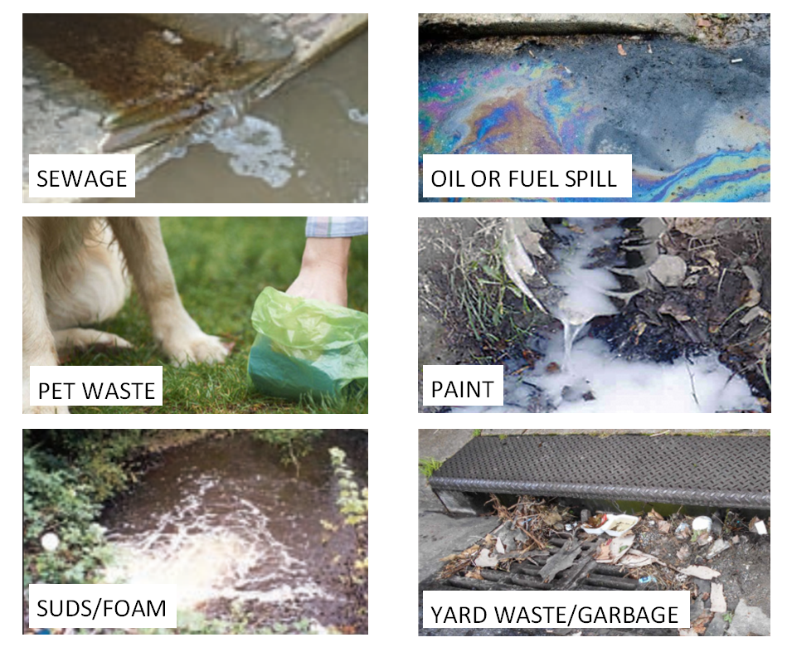
An Illicit Discharge is defined by the federal regulations as any discharge to a municipal separate storm sewer system (MS4) that is not entirely made of up stormwater except for fire-fighting activities. Examples of illicit discharges are sanitary wastewater, effluent from septic tanks, car wash wastewaters with cleaning agents, improper oil disposal, improper commercial waste disposal, radiator flushing disposal, laundry wastewaters, spills from roadway accidents, improper disposal of auto and household toxics.
It is important that no one dumps waste of any kind as described above onto the streets, drainage pipes, or any storm drain – as they are utilized for stormwater only. If you see someone dumping waste of any kind into the streams, streets, or storm drains, please report it immediately by completing this form and sending it to secretary@stowetwp.net or by calling Stowe Township at 412-331-4050 ext 9.

Reporter Information
☐ Anonymous – Please check if you would like to remain anonymous. If so, please add your number or email below so we can call you with questions regarding the discharge.
Name: Click or tap here to enter text.
Contact Phone Number: Click or tap here to enter text.
Contact Email Address: Click or tap here to enter text.
Date: Click or tap to enter a date.
Time of Discharge Observed:Click or tap here to enter text. ☐AM ☐PM

Location Information
Address of Observed Discharge: Click or tap here to enter text.
Closest Street/Landmark: Click or tap here to enter text.

Description of Observed Discharge – please explain what you saw and the suspected responsible party (business name, vehicle – license plate# or vehicle description, specific person, etc.)
Click or tap here to enter text.

Please clarify what kind of discharge was observed:
☐Dumping ☐Oil/solvents/chemicals ☐Sewage ☐Wash water, suds, etc.
☐Other: Click or tap here to enter text.

Odor
☐None ☐Sewage ☐Rotten Eggs/Natural Gas ☐Gasoline ☐Oil
☐Other: Click or tap here to enter text.

Clairty
☐Clear ☐Opaque ☐Cloudy ☐Grey ☐Sheen

Color
☐Red ☐Yellow ☐Brown ☐Green ☐Grey ☐White
☐Other: Click or tap here to enter text.

Solids or Floatables
☐Garbage ☐Sewage ☐Tissue ☐Suds ☐Scum
☐Other: Click or tap here to enter text.

Additonal Comments/Concerns:
Click or tap here to enter text.
Inspector Information – TO BE FILLED OUT BY INSPECTOR ONLY
Inspector Name(s): Click or tap here to enter text.
Date of Initial Investigation: Click or tap to enter a date.
Time of Inspection:Click or tap here to enter text. ☐AM ☐PM
Notes
☐No Investigation Made | Reason:Click or tap here to enter text.
☐Referred to different department/agency: | Department/Agency:Click or tap here to enter text.
☐Investigated: No Action Necessary

☐Investigated: Requires Action | Description of actions taken: Click or tap here to enter text.
Date case closed: Click or tap to enter a date.

Additional Comments/Notes:

Click or tap here to enter text.

